34.26: 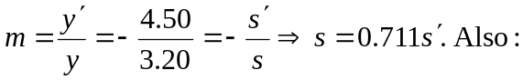
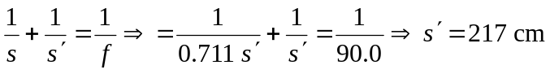(to the right).
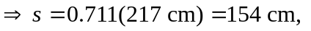and the image is real (since 